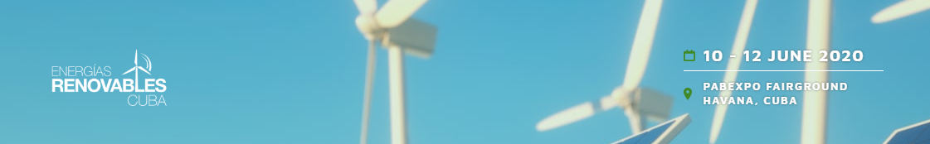

Mission to Cuba in the Renewable Energy and Energy Efficiency sectors
La Havana, 10 – 12 June 2020

Registration form
(to be filled in English)

Company:
Representative:
Role/Function:
E-mail:
Phone number:
Sub-Sector:
Existing business (products/services, n. of employees, turnover etc…):

More details about your products/services or investment project:

Specific requests for the BtoB meetings:

